Step 1 – Determine Position
Determine the position of the kitchen by putting markers into the ground at 59 1/4 inches to center. At the location of each post, place a marker.
Step 2 – Aligning
Determine the top of the finished floor, paving, lawn, etc. Tie the string line exactly 9" above the finished floor. IMPORTANT - Make sure string line is level.
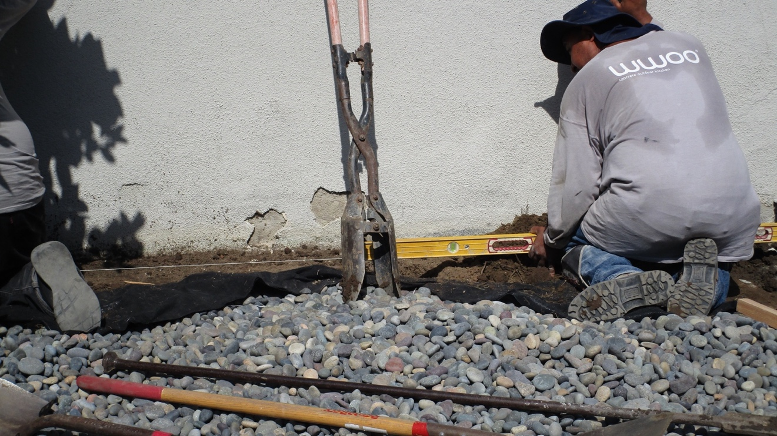
Step 3 – Dig Holes
Dig the post holes with a spade/post hole digger at each place marker: 10”-12" round by 36" below string line. 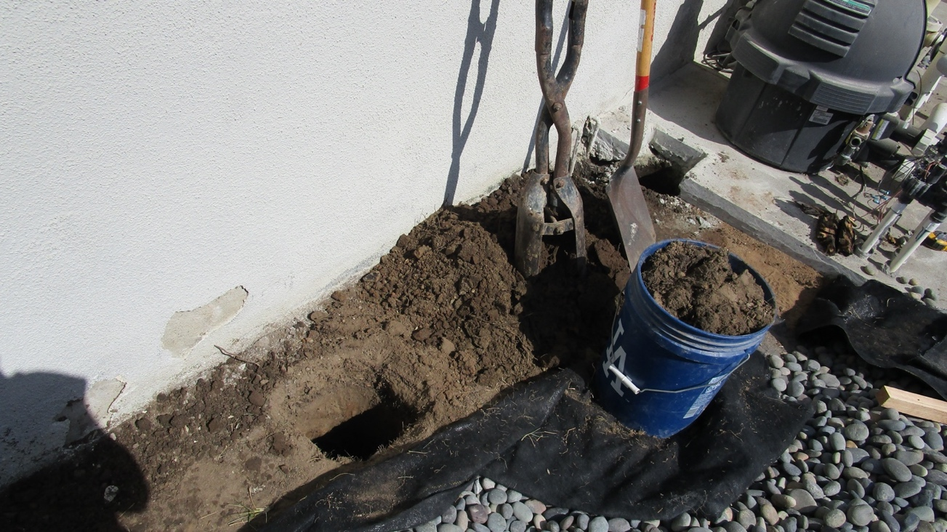

Step 4 – Marking
Measure from the top of each post using the chart below to mark on the post the 9”- above grade line. NOTE: 9” above grade will put the countertop @ 37”. Adjust measurement accordingly if a different counter height it desired. NOTE: Post will be approx. ½” higher than the top element when kitchen is complete.

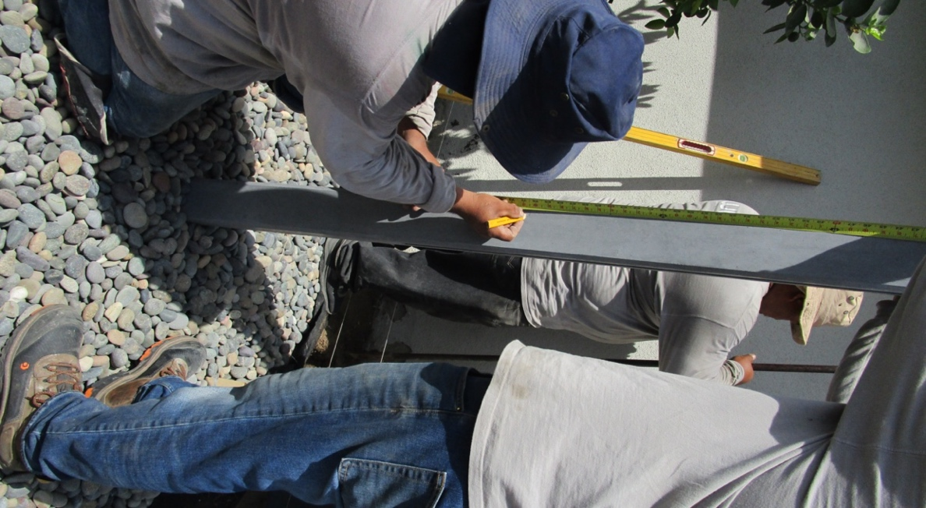

Measure from top of post:
4’3” Kitchen | 42.5”
5’4” Kitchen | 56.5”
6’6” Kitchen | 70.5”

Step 5
Place the first post in the hole, starting from one side of the kitchen with the marked line on the post, level with the string line.
Step 6 – Levels
IMPORTANT STEP! Make sure the post is exactly level and plumb. The post should also be square with the string line.
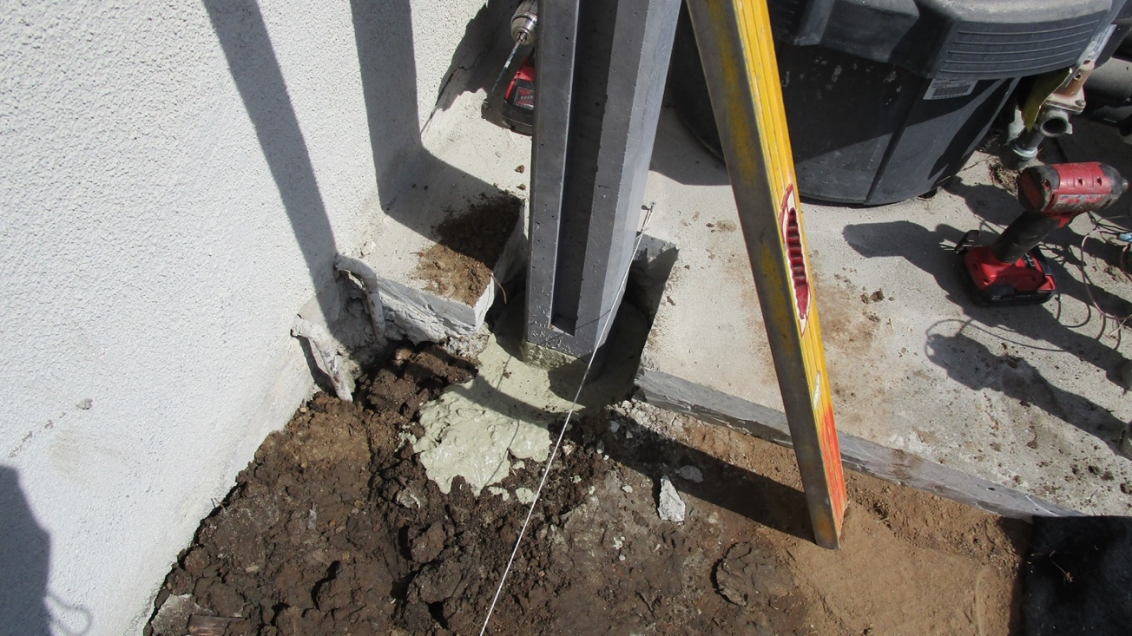
Step 7 – Add Concrete
Mix quick setting concrete in a bucket & pour into post hole.

Step 8 – Levels
Keep checking the post is precisely level, plumb and square. Allow the concrete to cure enough (if using quickset concrete, at least 30 minutes) to be ready to support the elements. (For other types of concrete see manufacturer’s packaging for instructions on required curing time)
Step 9
Insert first element into the channel of the post. Make sure the element is pushed to the back of the post channel. The top of the element should be level with the string. Use provided shims to lock the piece in place by tapping shims into the space between the post channel and the back of the first element.
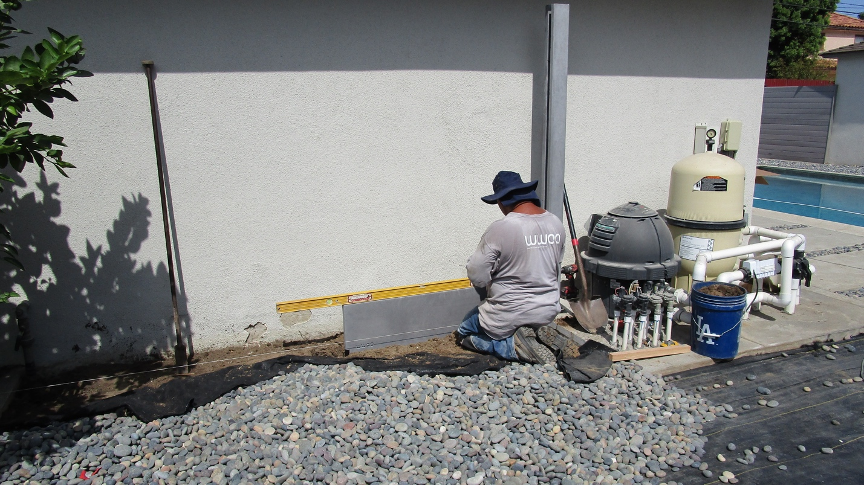

Important Weights:
Large Shelf | 265#
Small Shelf | 165#
Back Pieces | 88#
4’3” Post | 154#
5’4” Post | 187#
6’6” Post | 220#

Step 10
Place next element on top of the first element and push so it is seated at the back of the channel. Check for level, then secure piece with shims between back of the element and post channel. If 2nd element is a large shelf, us a 2 x 4 brace to steady the front corner of shelf opposite the post.

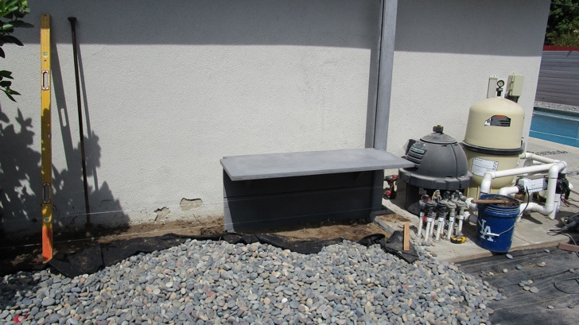

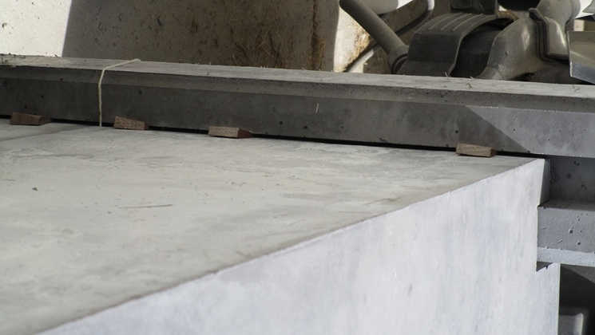

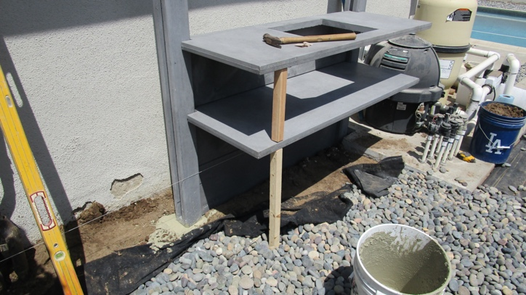

Step 11
Add 3rd element on top of the 2nd, brace corner of shelf with a 2x4 brace, and shim back of element as described above. NOTE: If installing kitchen close to another wall it may be necessary to add caulking between post channel & back of elements as you add each element. NOTE: See notes about caulking @ Step 15

Step 12
Ease the next post into the pre-dug hole. Carefully align the post channel with the edge of the 3 stacked elements and slide the post into position. The edge of the elements should be seated against the back of the post channel. Check for level from top of the first post to top of the second post. Check to make sure post is aligned and square with the string and post is plumb in both directions. Pour quick setting concrete around second post checking frequently for level & plumb as the concrete sets up.

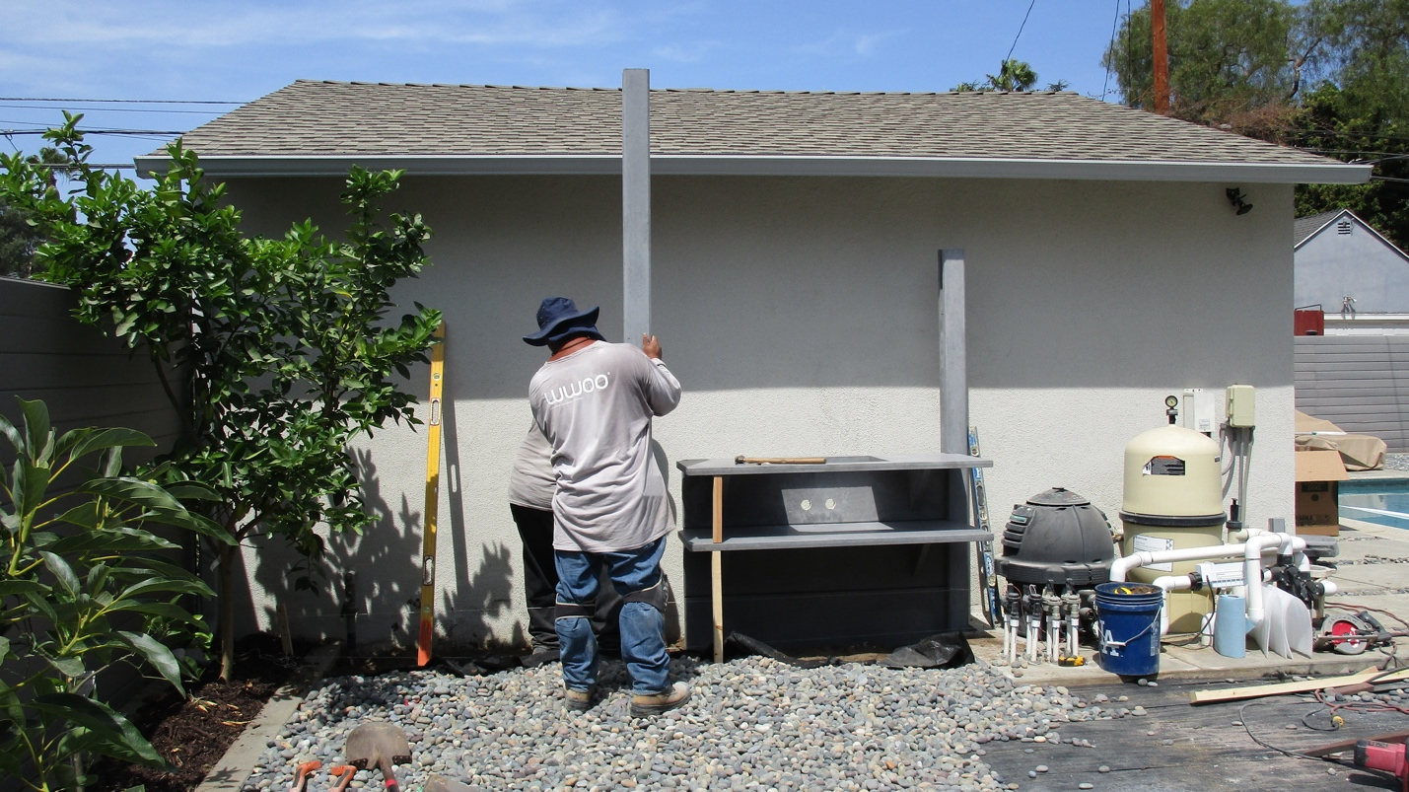

Step 13
Repeat steps 9 – 11 for each of the segments, so that the bottom 3 elements are in place. Important to align the shelves from segment to segment as you go, so front of each shelf is level with the next. Make sure that the gaps between shelves is parallel & equal distance.
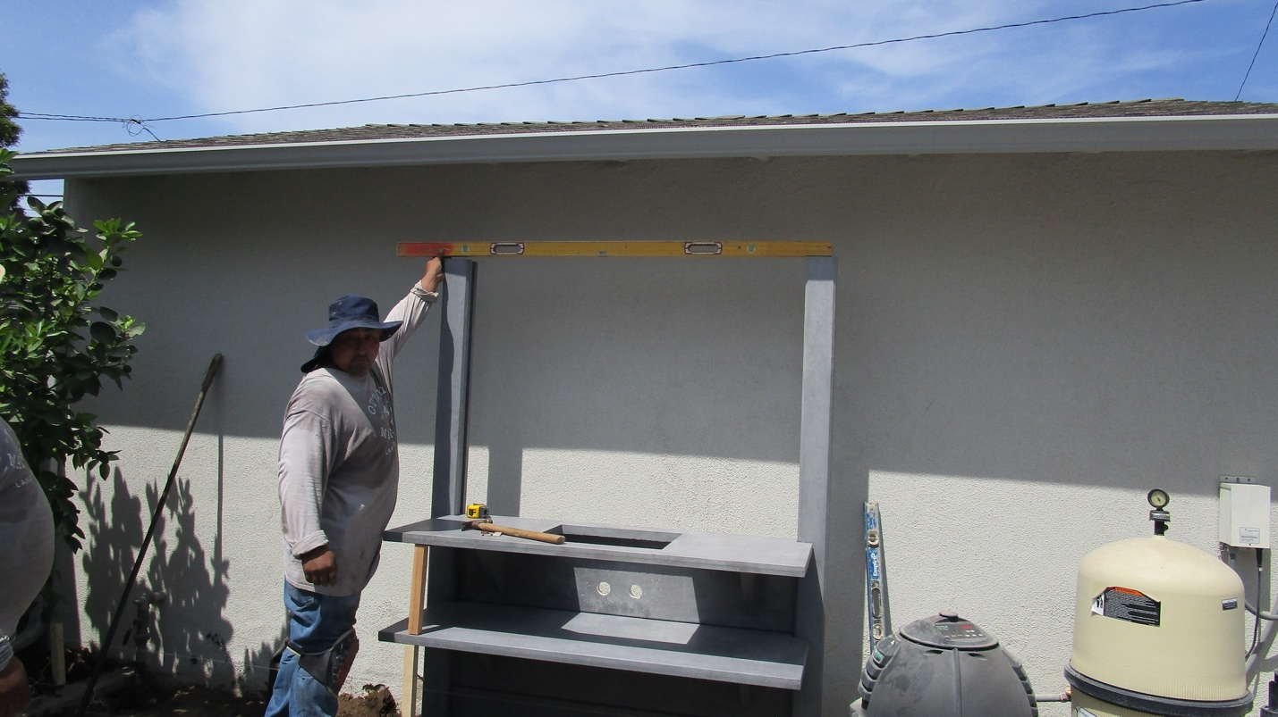

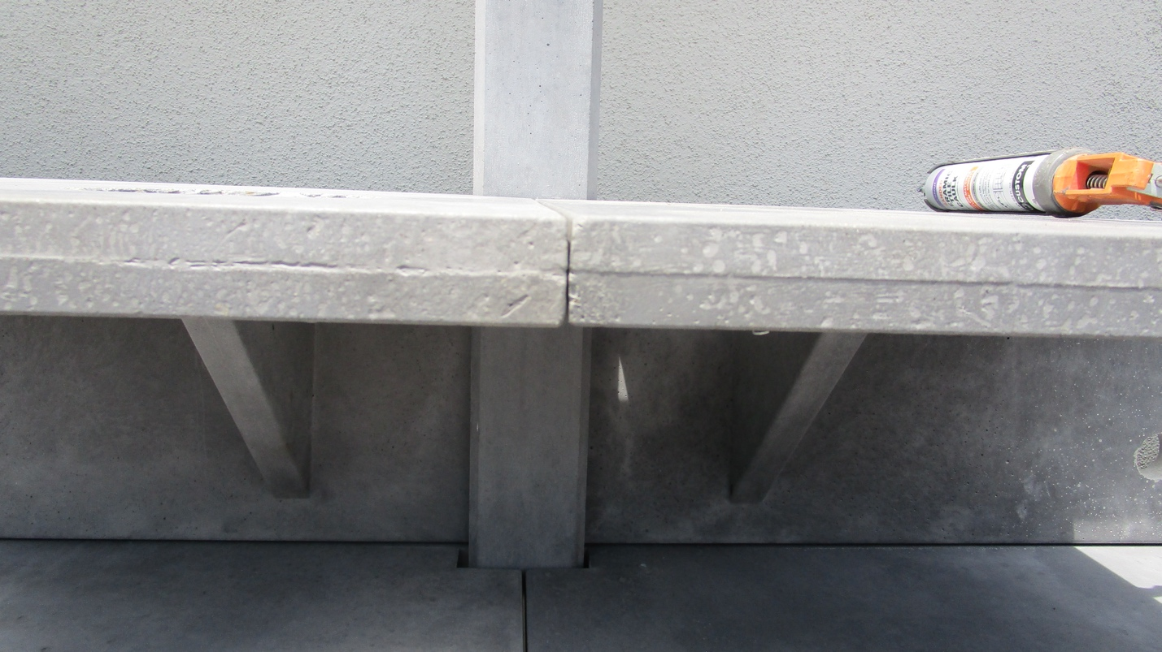

Step 14
After final post has been placed and concrete has set up, the upper elements can be lowered from the top into each segment by hand. Slowly lower the elements into the grooves of the posts, being careful to keep them level as they descend so that the pieces do not bind. Lock each element in place with shims as you go and finish each segment to the top before starting the next segment. Carefully align top shelves as you move from segment to segment, so they are level and gap is equal distance
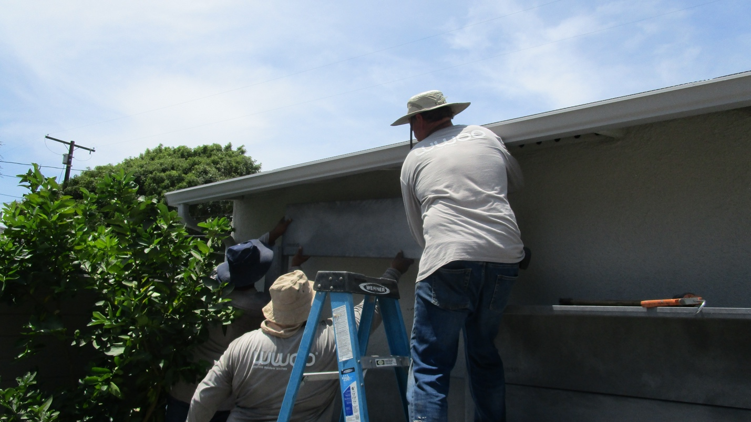
Step 15
After all elements have been set & shimmed into place, use a utility knife to cut all shims even with the edge of the posts. Then fill the gaps between the post channel and the back of each element, making sure to push the caulking into the gaps for a firm fit. NOTE: Use a sanded ceramic tile caulking that matches your kitchen color.

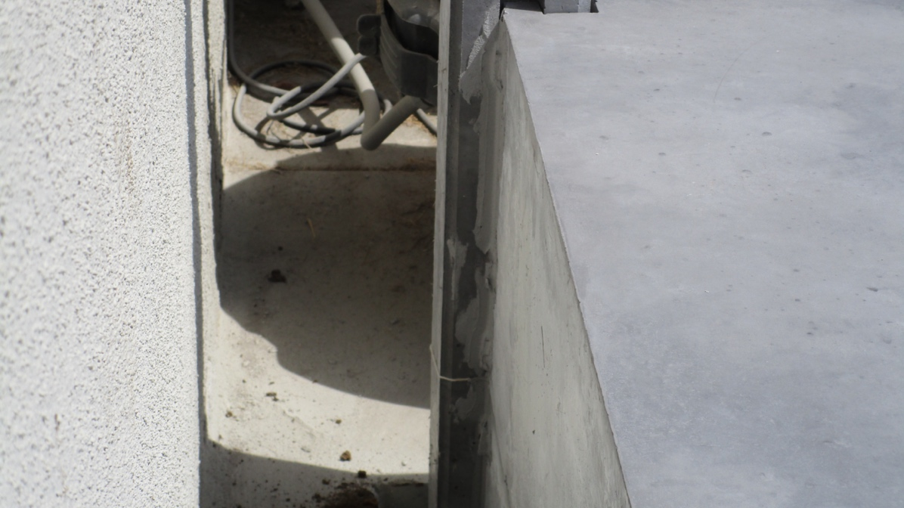

We recommend using “Custom Building Products” - Caulking:
White Kitchen | Caulking Color: Bone
Light Grey Kitchen | Caulking Color: Delorean Grey
Dark Grey Kitchen | Caulking Color: Pewter

Step 16 – Cover Plates
Secure stainless-steel plates on posts with provided bolt.
Step 17 – WWOO Styling
Place all accessories and ENJOY your new WWOO outdoor kitchen. Visit our WWOO website for inspiration, or find us on Facebook, or Instagram by searching @wwoocalifornia.
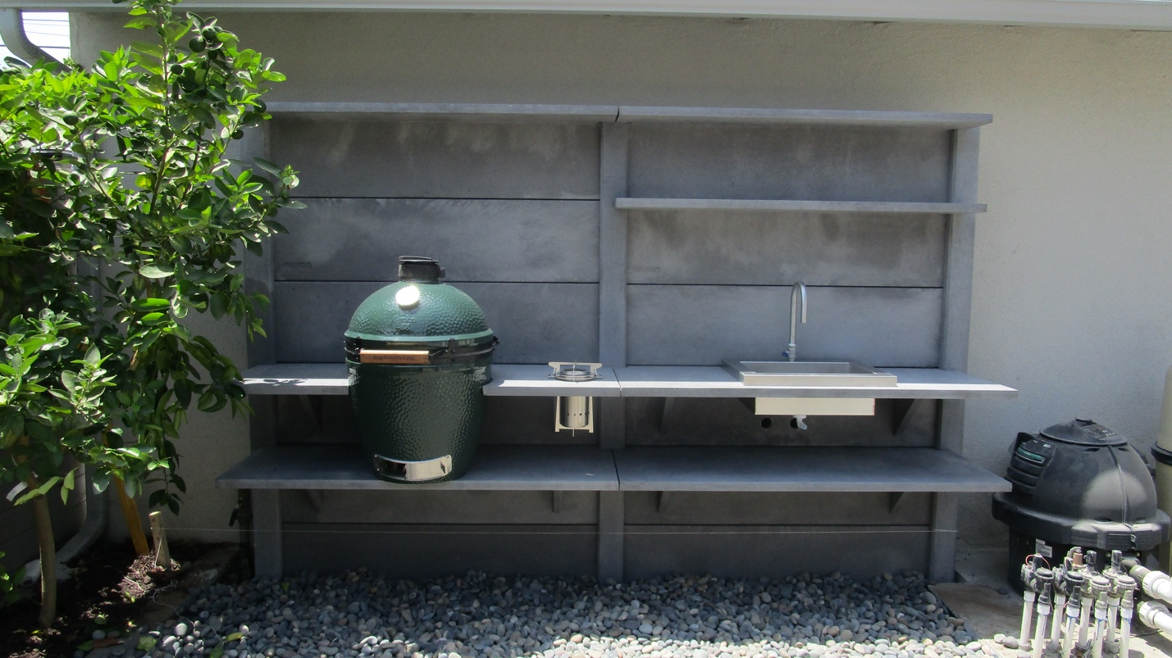

NEED Help? Please contact us by emailing us at info@wwoous.com or by calling our office at 310-648-8030

